HI 192 List of Project SS 25-26
DelaCruz/Doria/Rodriguez : (Optimizer and Learning Rate Study of Ovarian Cancer Prediction)
1. STRAMPN-HISTOPATHOLOGICAL IMAGES FOR OVARIAN CANCER PREDICTION
https://ieee-dataport.org/documents/strampn-histopathological-images-ovarian-cancer-prediction
Ovarian Cancer: 481 images
No Ovarian Cancer: 506 images
Total: 987 images
Balanced
75% training, 25% testing; training further split into 70% training 30 % validation
(247 images testing - 740 images training: 518 images training, 222 images validation)
Using transfer learning: VGG19, EfficientNetB3, ResNet50, DenseNet121
Fixed: drop-out (0.6, 0.4, 0.3), dense nodes (256, 128, 64), no of epochs:50, input size (256x256); batch size 32
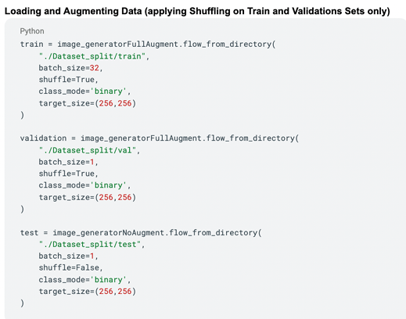

Apply pre-processing techniques: normalization, image shuffling, augmentation, train-test split
Should have augmentation on the training images only
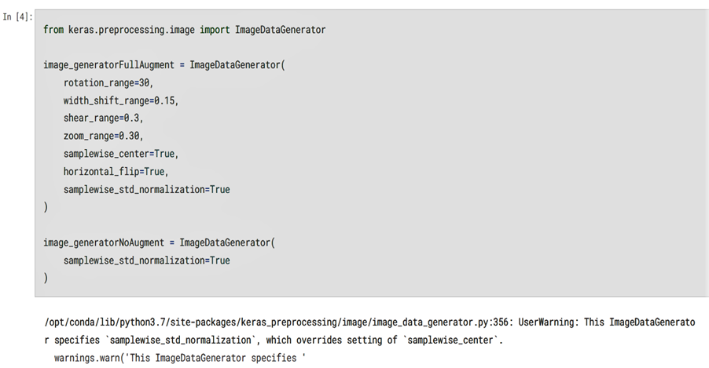
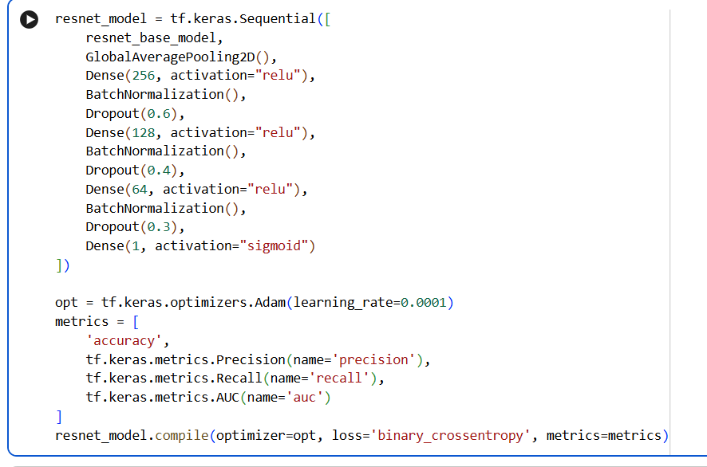

Main Experiments: to run at LR=0.0001, 0.00001, 0.000001
Adam (Adaptive Moment Estimation optimizer)
Adagrad (Adaptive Gradient optimizer)
Adamax (Maximum adaptive moment estimation optimizer)
AdaDelta
SGD (Stochastic Gradient Descent)
RMSProp (Root Mean Square Propagation optimizer)
TOTAL SIMULATION MODELS: 4 x 3 x 7= 84

Main Metric: Accuracy and AUC; but need to get all metrics (accuracy, recall, precision, specificity, F1-score and AUC)
Binary classification: With Cancer vs Without Cancer

Make sure to generate accuracy and loss curves for every 84 simulation.
Make sure to generate all AUC curves for all 84 simulations
=====================================================================

Balmaceda/Perillo/Acosta: (Batch Size Study of Ovarian Cancer Prediction)
2. STRAMPN-HISTOPATHOLOGICAL IMAGES FOR OVARIAN CANCER PREDICTION
https://ieee-dataport.org/documents/strampn-histopathological-images-ovarian-cancer-prediction
Ovarian Cancer: 481 images
No Ovarian Cancer: 506 images
Total: 987 images
Balanced
Create a Base CNN consisting of 3 sequential layers
75% training, 25% testing; training further split into 70% training 30 % validation
(247 images testing - 740 images training: 518 images training, 222 images validation)
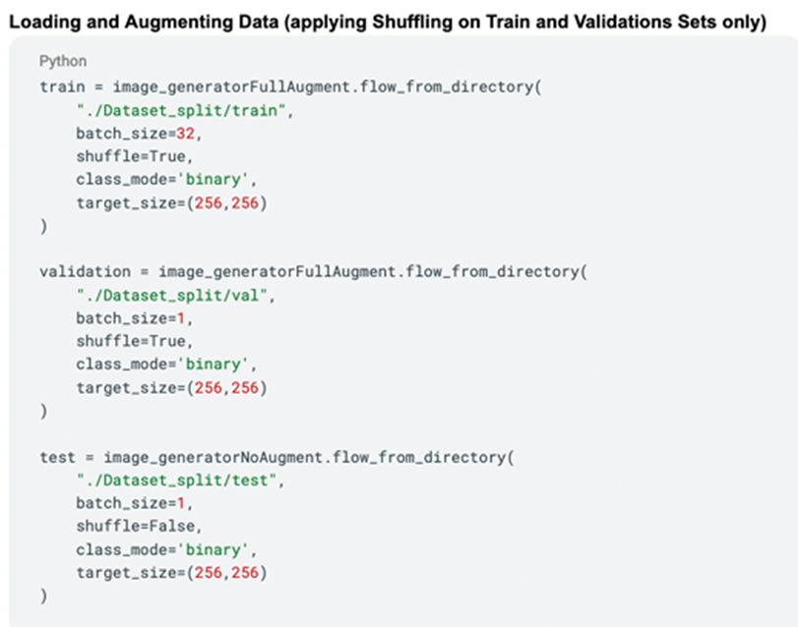

Apply pre-processing techniques: normalization, image shuffling, augmentation, train-test split

Should have augmentation on the training images only
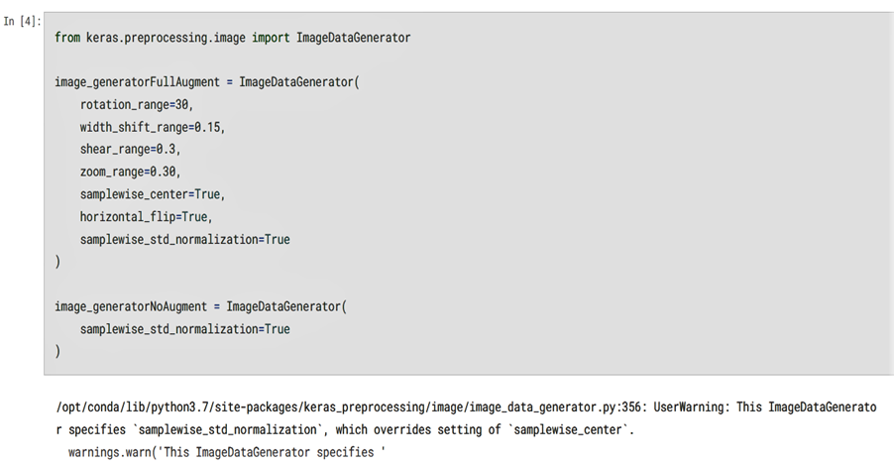

Focus on the Testing various Batch Size: 2,4,8,16,32,64, 128,256,512 (9 batch size values)

Fixed: drop-out (0.3), dense nodes (32), no of epochs:50, input size, optimizer (Adam), learning rate (0.0001)

Compare results of Batch Sizes among Base CNN and Pre-Trained Models
Pre-Trained Models: VGG19, ResNet50, InceptionV3, DenseNet201
TOTAL: 9 x 5 = 45 simulation models

Main Metric: Accuracy and AUC; but need to get all metrics (accuracy, recall, precision, specificity, F1-score and AUC)
Binary classification: With Cancer vs Without Cancer

Make sure to generate accuracy and loss curves for every 45 simulations.
Make sure to generate all AUC curves for all 45 simulations

=======================================================================
Abogado/Magante/Tan: Dental OPG Xray Study
3. Dental OPG Xray Study
https://ieee-dataport.org/documents/dental-opg-xray-dataset

The dataset consisted of panoramic dental radiographs, categorized into six major classes: healthy teeth, caries, impacted teeth, infections, fractured teeth, and broken-down crowns/roots (BDC/BDR)

• Healthy Teeth: 223
• Caries: 119
• Impacted Teeth: 87
• Broken Down Crown/ Root: 52
• Infection: 23
• Fractured Teeth: 13

In this case, we shall limit to multiclass involving 4 classes removing the infection and fractured teeth classes

481 images (using 80-20 split, with 80 % training further split into 75% training and 25% validation)
(96 testing images; 385 training images- 289 training and 96 validation images)

Create a Base CNN consisting of 3 sequential convolutional layers with 8, 16, 32 number of nodes, Optimizer Adam, Learning Rate : 0.0001
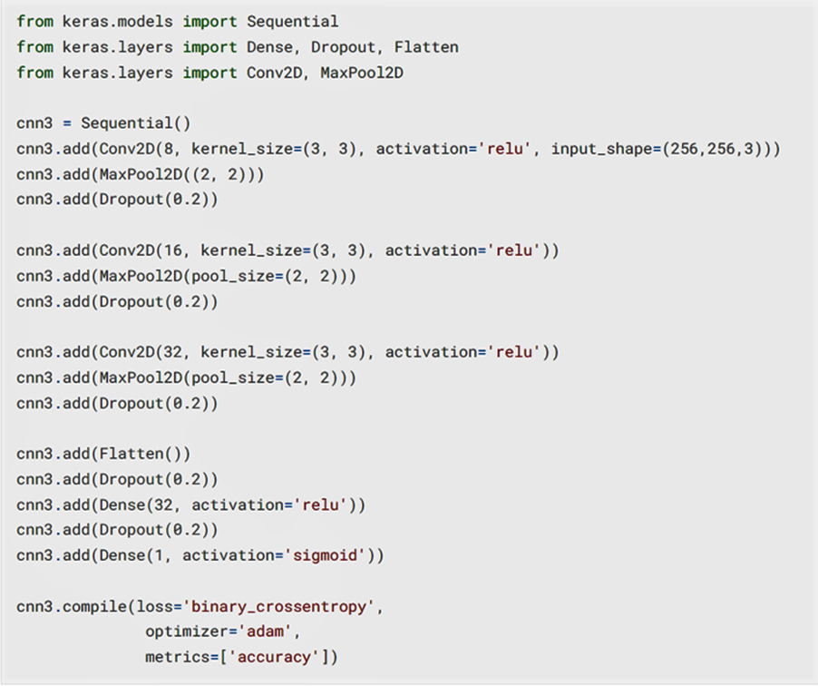

Apply pre-processing techniques: image resizing (640x640); normalization, image shuffling, augmentation, train-test split
Should have augmentation on the training images only
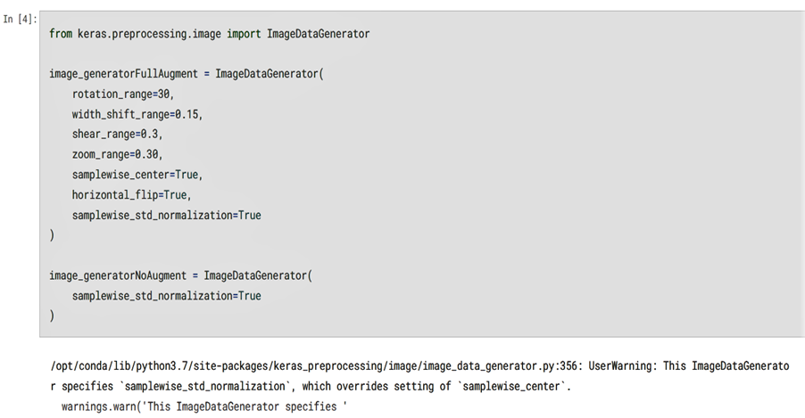

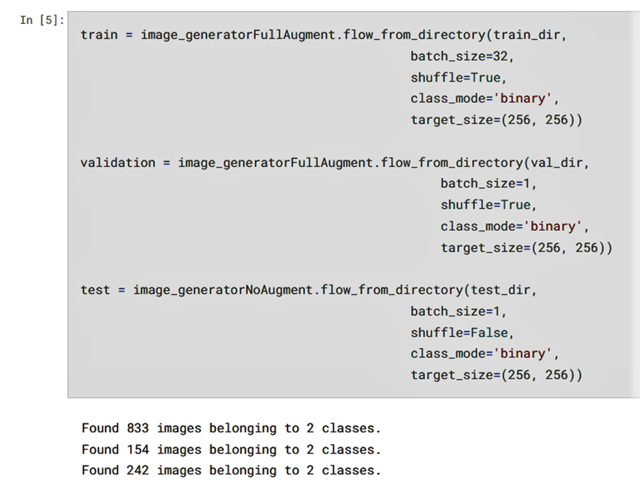

Be sure to check class weights to address imbalance
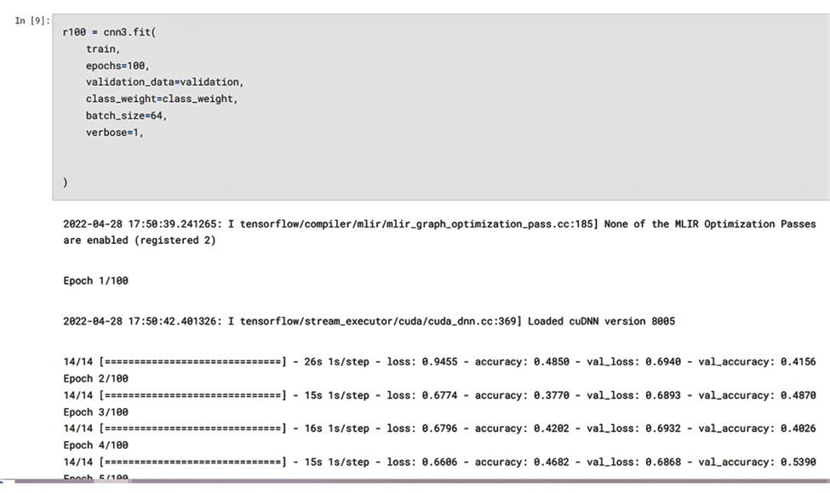

Experiment on the following network parameters:
- drop-out (0.2, 0.5, 0.7)
- batch size (16, 32, 64, 128)
- dense nodes (16,32,64)
Fixed: no of epochs (50), learning rate (0.0001), optimizer (Adam), input shape (640x640)
make sure to generate loss and accuracy curves for both training and validation data
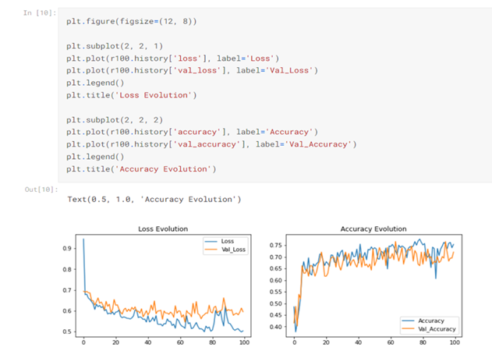

Compare with Pre-trained CNN Architecture (VGG16, ResNet34, DenseNet121)

Total MODELS: 3 (drop outs) x 4 (batch size) x 3 (dense nodes) x 4 models (basem vgg16m resnet34, densenet121) = 144 models
Metric: MCC, accuracy, recall, specificity, precision, F1scores, AUC
Make sure to generate accuracy and loss curves for every 144 simulations.
Make sure to generate all AUC curves for all 144 simulations

=======================================================================
4. Baui/De Vera/Lumain/Surban

3. Dental OPG Xray Study
https://ieee-dataport.org/documents/dental-opg-xray-dataset
The dataset consisted of panoramic dental radiographs, categorized into six major classes: healthy teeth, caries, impacted teeth, infections, fractured teeth, and broken-down crowns/roots (BDC/BDR)

• Healthy Teeth: 223
• Caries: 119
• Impacted Teeth: 87
• Broken Down Crown/ Root: 52
• Infection: 23
• Fractured Teeth: 13

In this case, we shall limit to binary class involving 2 classes (healthy teeth vs non-healthy teeth)

517 images (using 80-20 split, with 80 % training further split into 75% training and 25% validation)
(103 testing images; 414 training images- 310 training and 104 validation images)

Create a Base CNN consisting of 3 sequential convolutional layers with 8, 16, 32 number of nodes, Optimizer Adam, Learning Rate : 0.0001 Fixed: no of epochs (50), Dense Nodes 32

Apply pre-processing techniques: image resizing (640x640); normalization, image shuffling, augmentation, train-test split
Should have augmentation on the training images only




Be sure to check class weights to address imbalance


make sure to generate loss and accuracy curves for both training and validation data


Focus on the Testing various Batch Size: 2,4,8,16,32,64, 128, 256 (8 batch size values)

Fixed: drop-out (0.3), dense nodes (32), no of epochs:50, input size, optimizer (Adam), learning rate (0.0001)

Compare results of Batch Sizes among Base CNN and Pre-Trained Models
Pre-Trained Models: VGG19, ResNet50, InceptionV3, DenseNet201
TOTAL: 8 batch size x 5CNN models (base and pretrained) =40 models

Metric: MCC, accuracy, recall, specificity, precision, F1scores, AUC
Make sure to generate accuracy and loss curves for every 40 simulations.
Make sure to generate all AUC curves for all 40 simulations

========================================================================

5. Agudo/Olaguera/Buizon: Dragon fruit Plant Image Optimizer Study

DRAGON FRUIT PLANT IMAGE DATASET
https://ieee-dataport.org/documents/dragon-fruit-plant-image-dataset

600 Images
300 Images
300 Images

600 images (using 70-30 split, with 70 % training further split into 75% training and 25% validation)
(180 testing images; 420 training images- 315 training 105 validation images)
Comdoenca – with the disease
Endoenca- without the disease


Using transfer learning: VGG19, EfficientNetB3, ResNet50, DenseNet121
Fixed: drop-out (0.6, 0.4, 0.3), dense nodes (256, 128, 64), no of epochs:50, input size (256x256); batch size 32

Apply pre-processing techniques: normalization, image shuffling, augmentation, train-test split
Should have augmentation on the training images only



Main Experiments: to run at LR=0.0001, 0.00001, 0.000001
Adam (Adaptive Moment Estimation optimizer)
Adagrad (Adaptive Gradient optimizer)
Adamax (Maximum adaptive moment estimation optimizer)
AdaDelta
SGD (Stochastic Gradient Descent)
RMSProp (Root Mean Square Propagation optimizer)

Main Metric: Accuracy and AUC; but need to get all metrics (accuracy, recall, precision, specificity, F1-score and AUC)
Binary classification: With Disease (COmdoenca) vs Without Disease (Endoenca)
TOTAL MODELS: 3 learning rates x 6 optimizers x 4 pretrained models = 72 simulations
Make sure to generate accuracy and loss curves for every 72 simulations.
Make sure to generate all AUC curves for all 72 simulations

